Task-1:
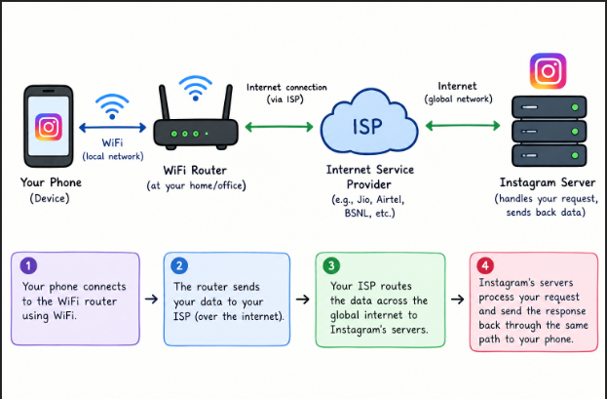

Task-2:
Wifi Router LAN & WAN
Smartphone LAN & WAN
Smart TV LAN
Laptop LAN
SmartWatchPAN

Task-3:
- Internet:
The internet is global network, which connects systems or devices in huge number, With use of internet we can access youtube, Instagram and ect.
For example, I am going to any café and I will connect my smartphone with café’s wifi then after I will use google.

- Intranet:
The intranet is a privet network, which is used by college/University or Organizations.
For example, Students access college portal for announcements, study material or exam details.

Task-4:
For Example, When you tap Search in Google Maps, your search query is sent as an encrypted HTTPS request over Wi-Fi or mobile data to a nearby router or cell tower. From there, your Internet Service Provider (ISP) forwards the data through fiber-optic networks and internet exchange points until it reaches Google's data center. Google's load balancers and mapping servers then process your request using geospatial databases to find places or calculate routes. The results are packaged into a response and sent back through the ISP network to your device. Finally, the Google Maps app displays the results on your screen, including map tiles, location pins, and relevant details.

